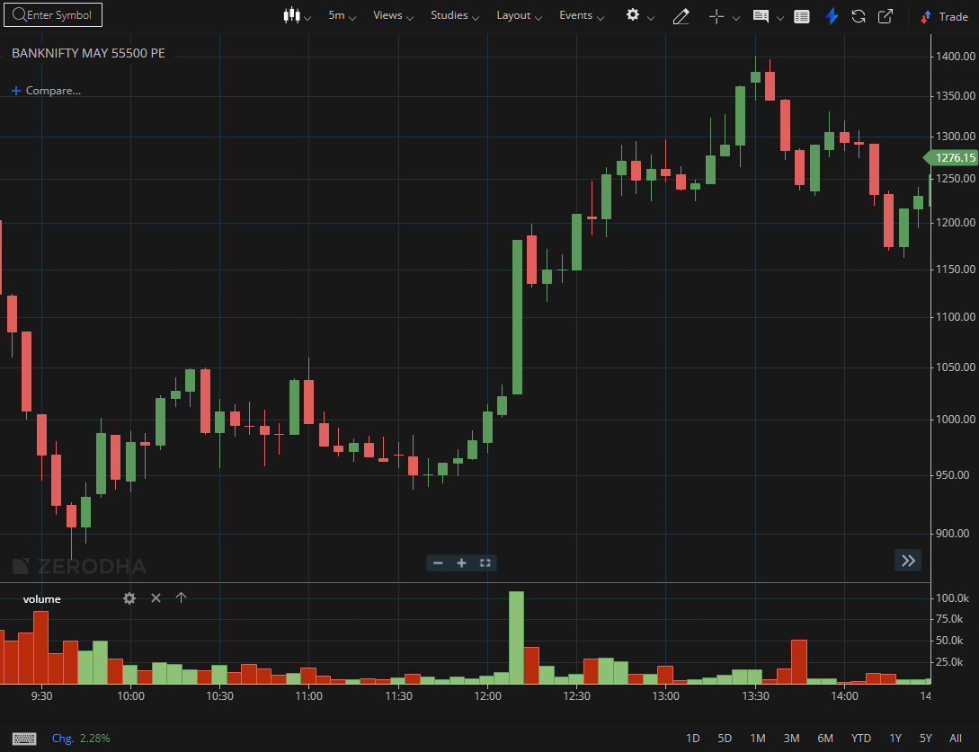
BANKNIFTY MAY 55500 PE

1.Multiple tests of resistance weaken it, increasing breakout probability.
2.Bullish engulfing patterns at support indicate renewed buying interest.
3.Sustained trading above VWAP across sessions signals institutional support.

