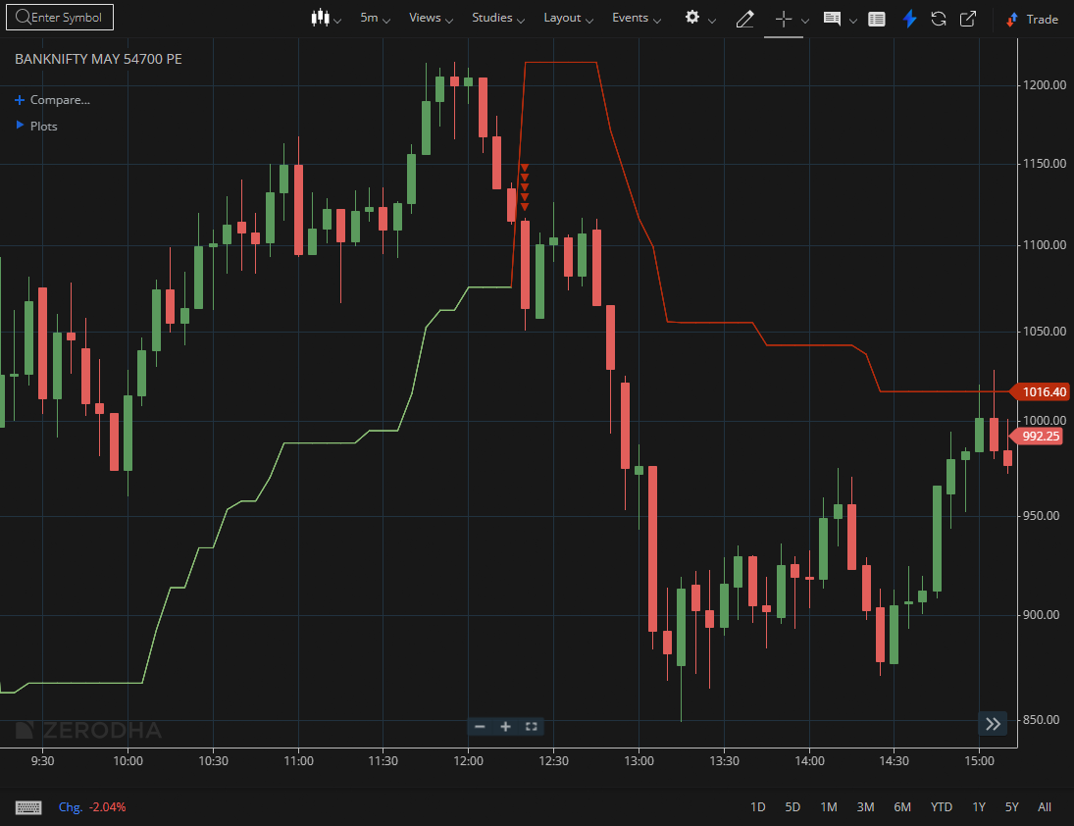

BANKNIFTY MAY 54700 PE

1.Bullish engulfing patterns at support indicate renewed buying interest.
2.Sustained trading above VWAP across sessions signals institutional support.
3.A shallow retracement after a strong rally suggests underlying strength.

