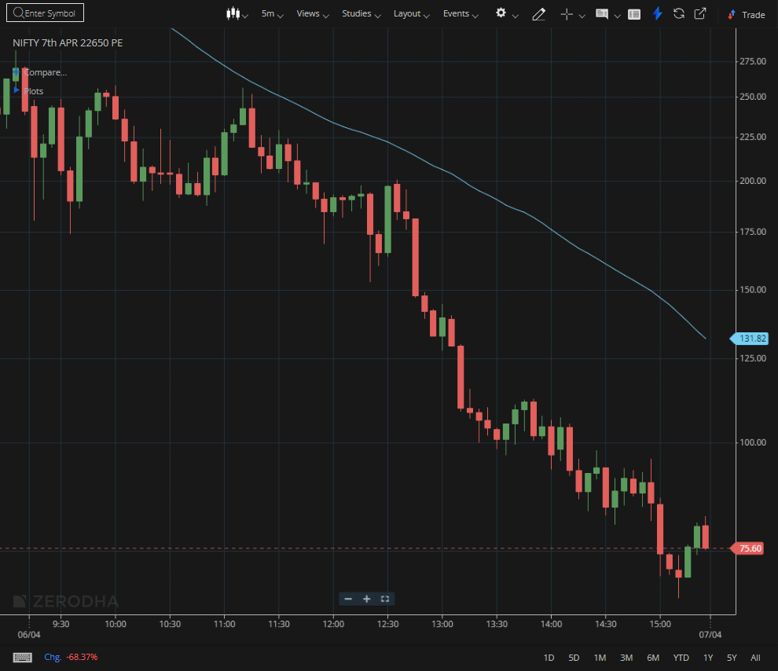
NIFTY 7TH APR 22650 PE
1.Adherence to an ascending trendline indicates steady demand from buyers.
2.A confirmed retest of the breakout area reinforces the shift from resistance to support.
3.Higher volume during the breakout points to involvement from institutional participants.

