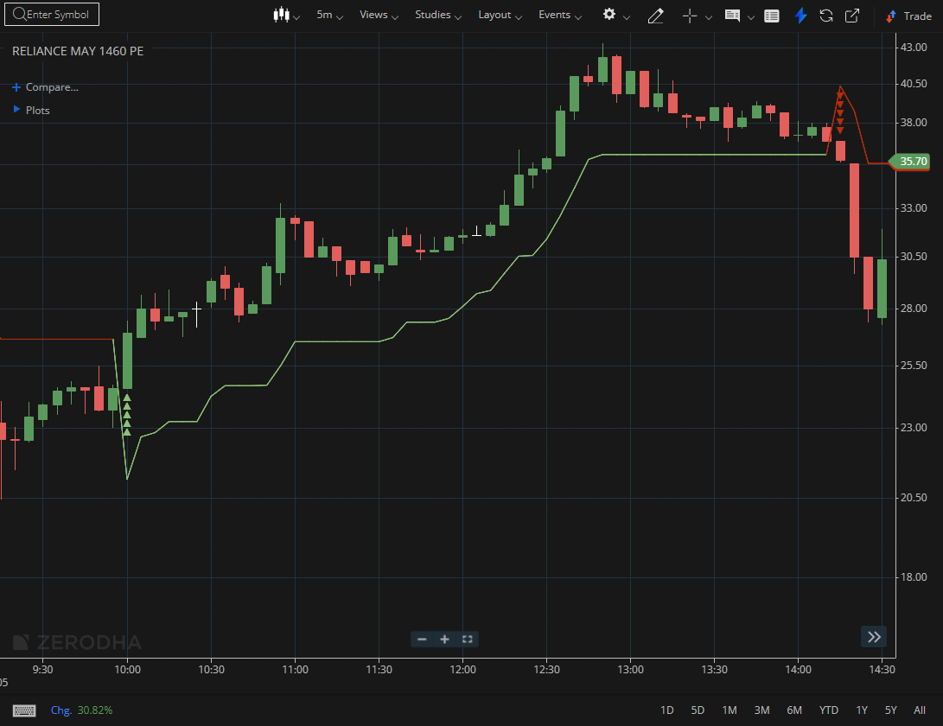

RELIANCE MAY 1460 PE

1.Staying above the previous swing high signals that bullish momentum remains intact.
2.A steady formation of higher highs and higher lows points to a clearly established uptrend.
3.Breaking out of a long consolidation phase, especially with rising volume, highlights underlying strength

