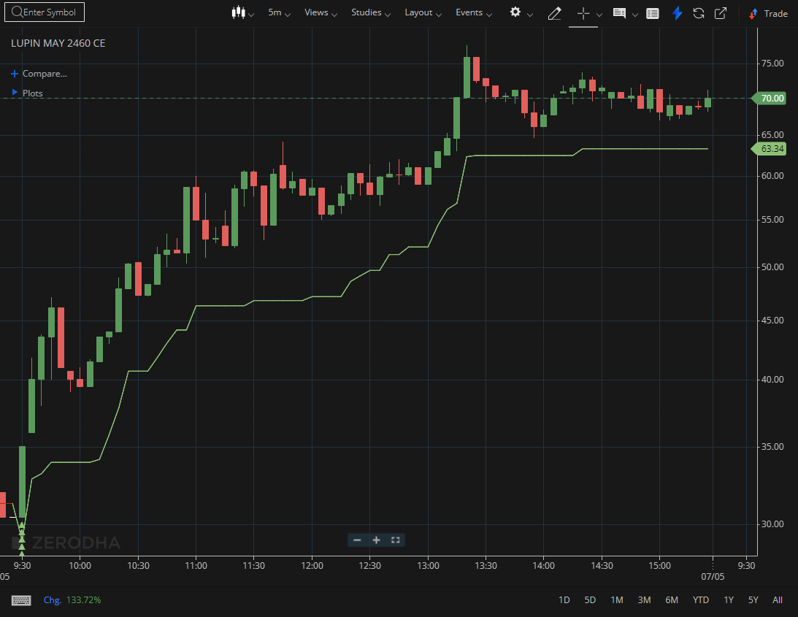
LUPIN MAY 2460 CE

1.Respecting an upward-sloping trendline reflects consistent buying interest.
2.A clean retest of a breakout level confirms that former resistance has turned into support.
3.Higher volume during breakouts often indicates participation from larger players.

