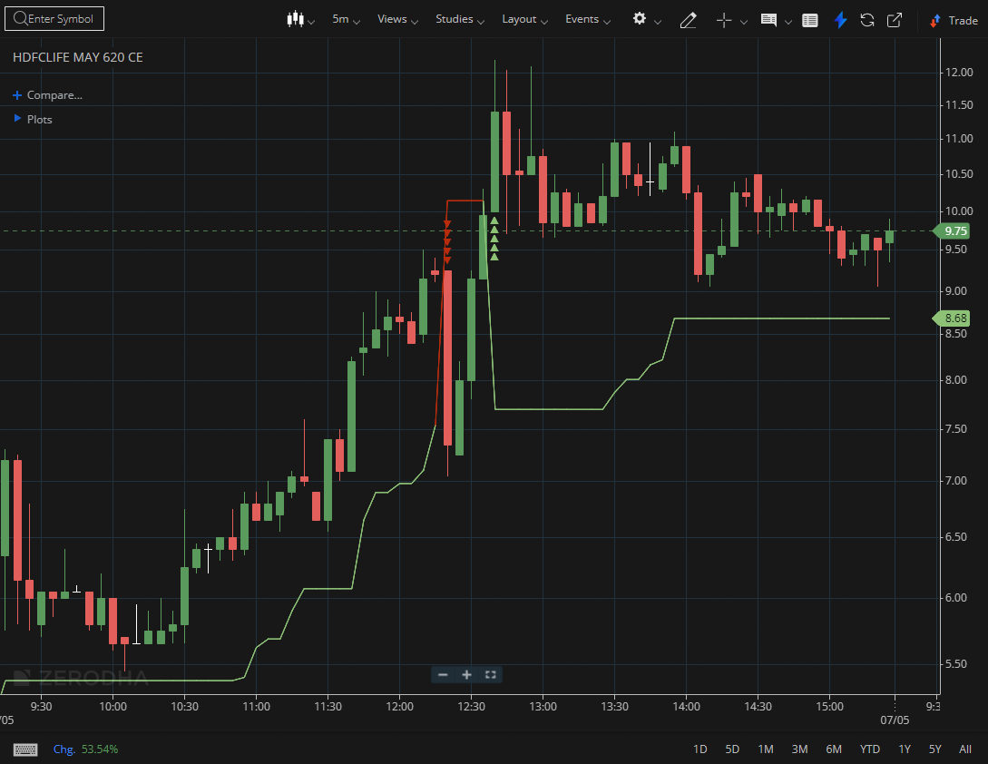
HDFCLIFE MAY 620 CE

1.Holding above key moving averages further strengthens the trend’s credibility.
2.Tight price movement can suggest accumulation before a potential expansion.
3.A bullish flag pattern typically signals continuation of the ongoing trend.

