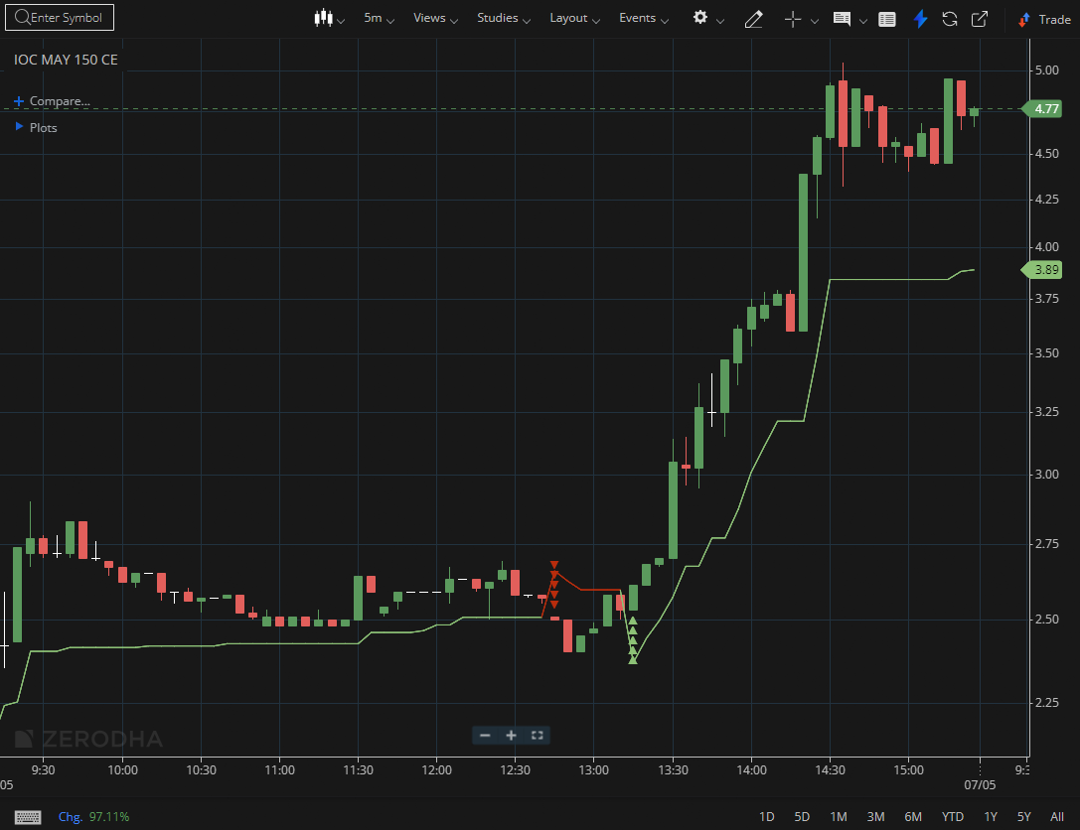

IOC MAY 150 CE

1.Trading above VWAP shows buyers are in control during the session.
2.Long upper wicks near resistance hint at rejection and selling pressure.
3.Approaching a demand zone may attract fresh buying interest.

