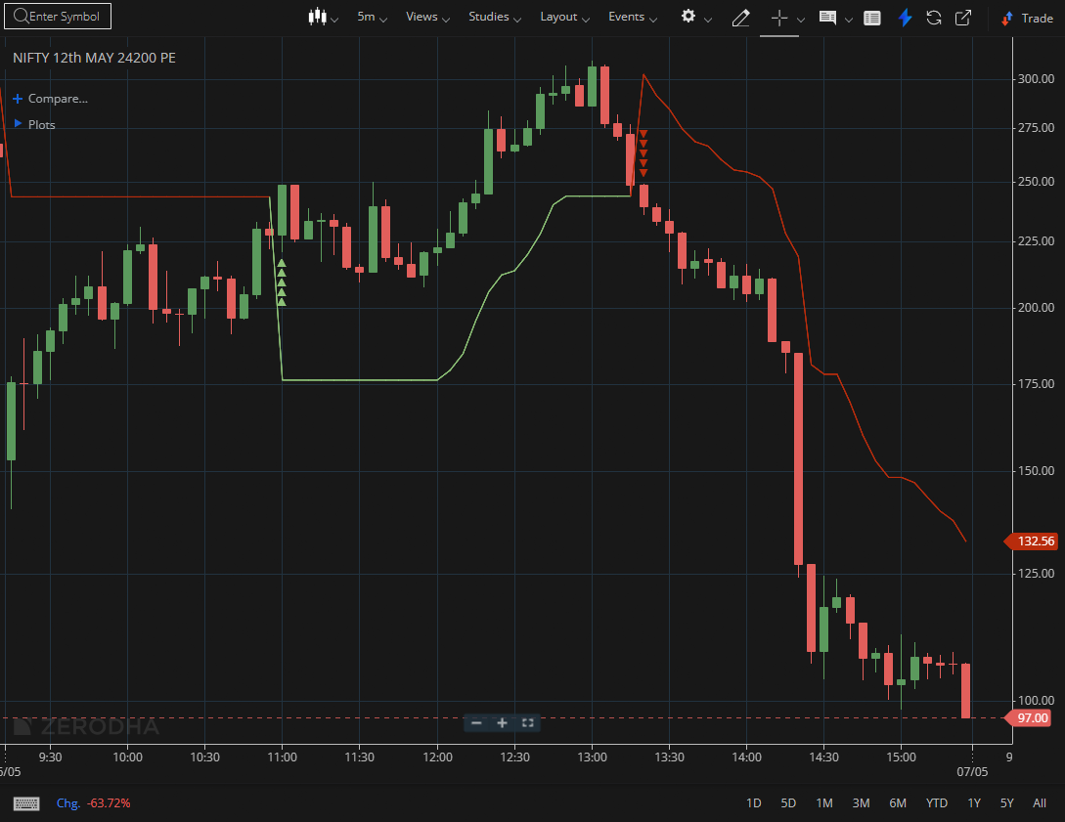
NIFTY MAY 24200 PE

1.Repeated rebounds from support levels suggest accumulation.
2.Bullish divergence near support can indicate a possible upside reversal.
3.A volatility squeeze followed by expansion often leads to a strong directional move.

