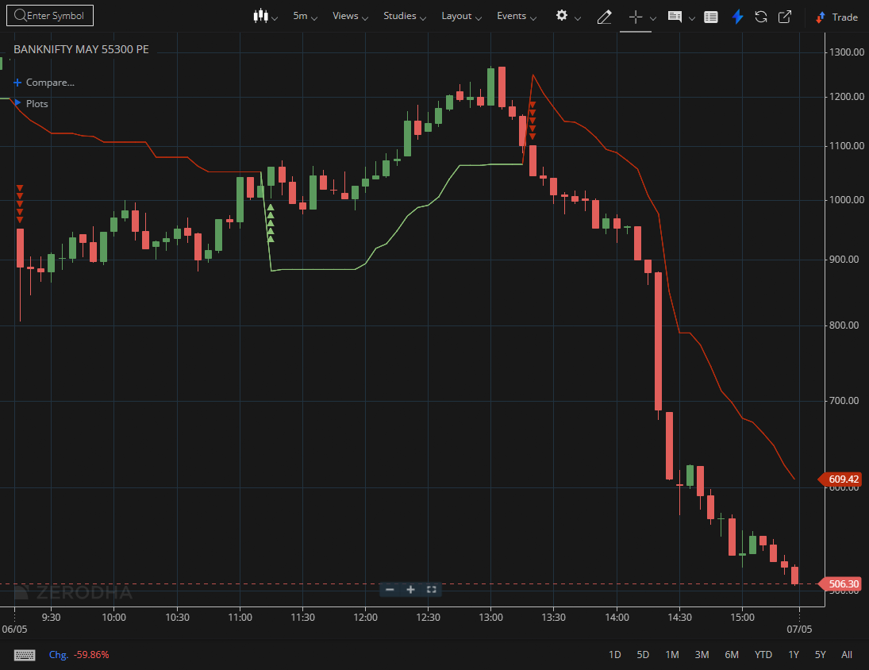

BANKNIFTY MAY 55300 PE

1.A breakout above a descending trendline can mark the beginning of a reversal.
2.Multiple rejections followed by a breakout indicate strong bullish conviction.
3.Outperforming the broader index reflects notable relative strength.

