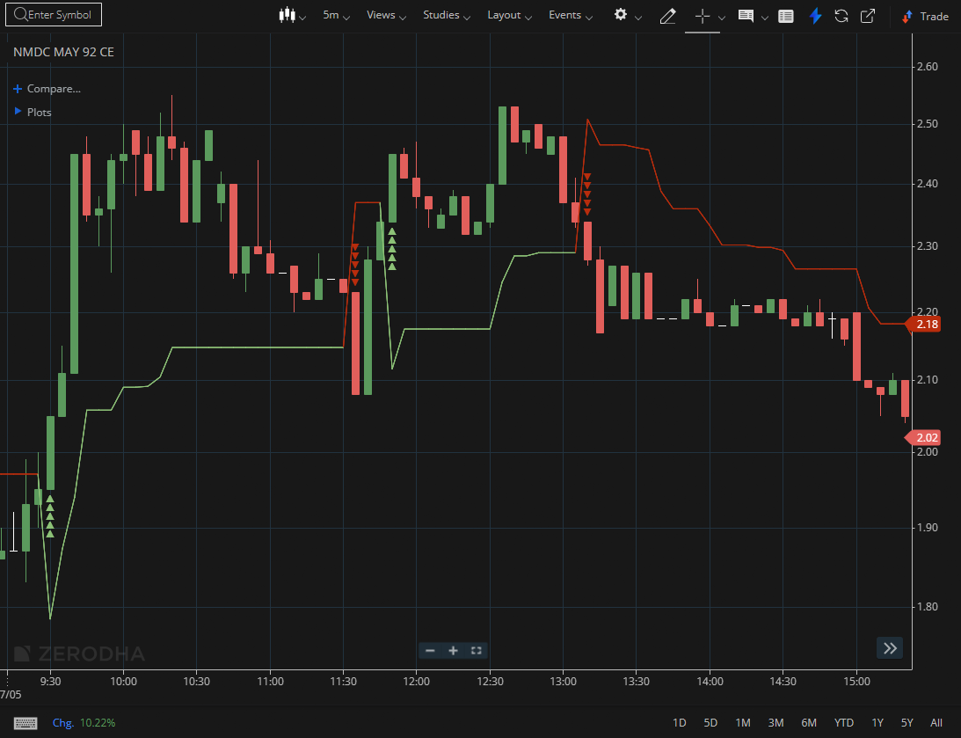
NMDC MAY 92 CE

1.Long upper wicks near resistance hint at rejection and selling pressure.
2.Approaching a demand zone may attract fresh buying interest.
3.A breakout above a descending trendline can mark the beginning of a reversal.

