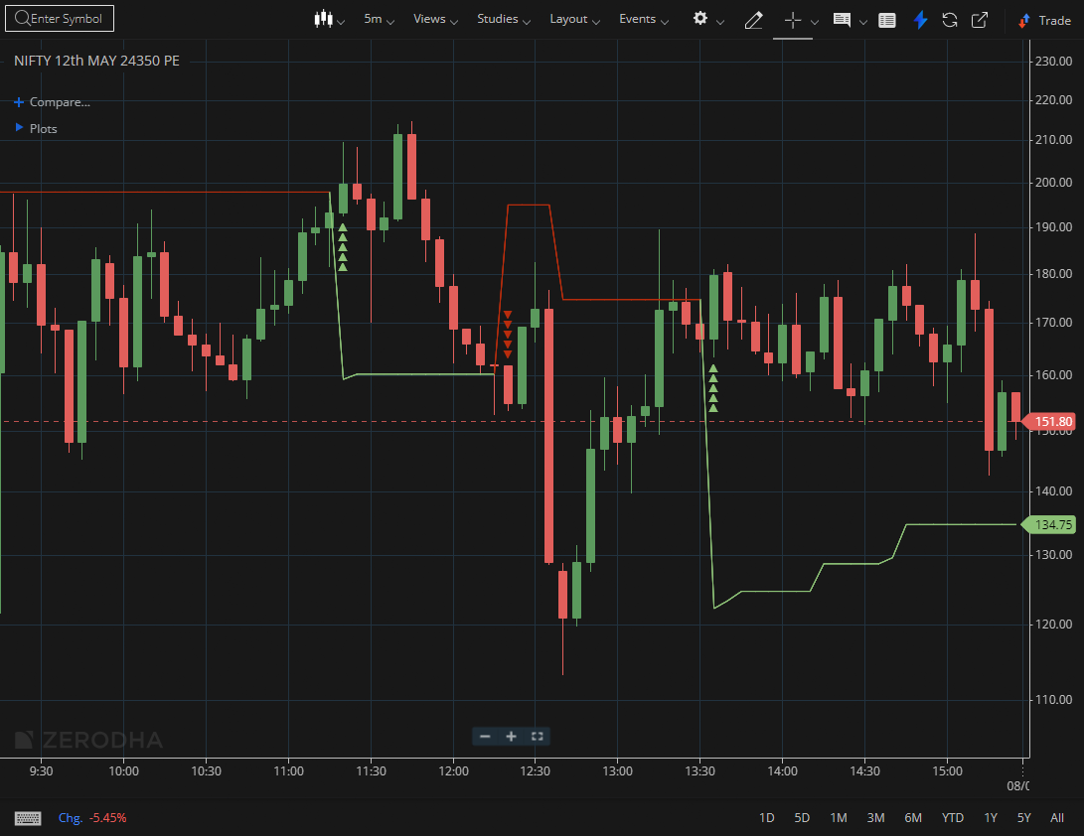

NIFTY MAY 24350 PE

1.Tight price movement can suggest accumulation before a potential expansion.
2.A bullish flag pattern typically signals continuation of the ongoing trend.
3.Trading above VWAP shows buyers are in control during the session.

