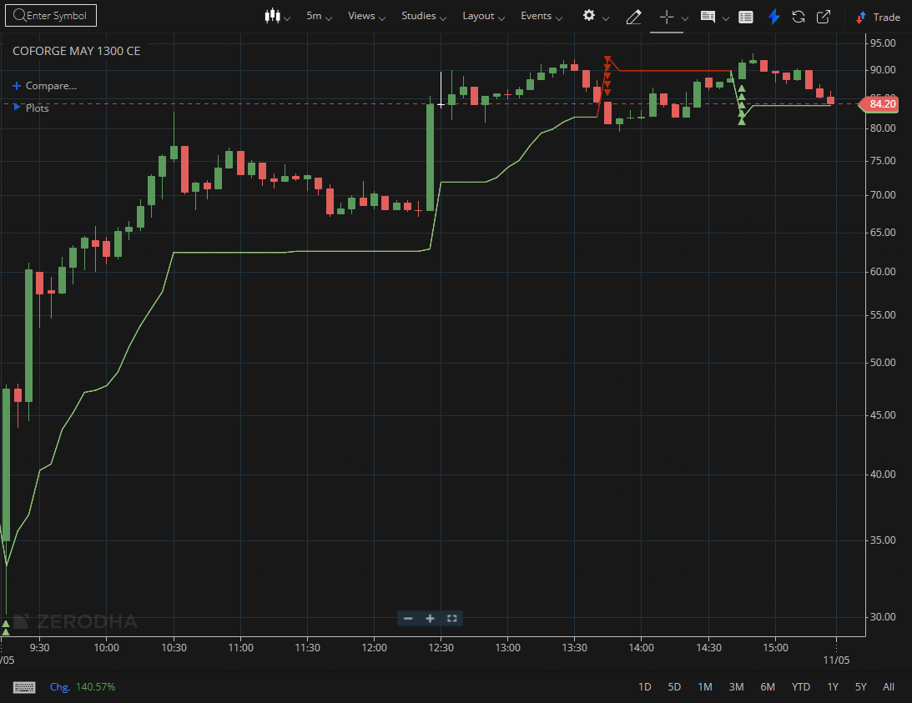
COFORGE MAY 1300 CE

1.Outperforming the broader index reflects notable relative strength.
2.Repeated rebounds from support levels suggest accumulation.
3.Bullish divergence near support can indicate a possible upside reversal

