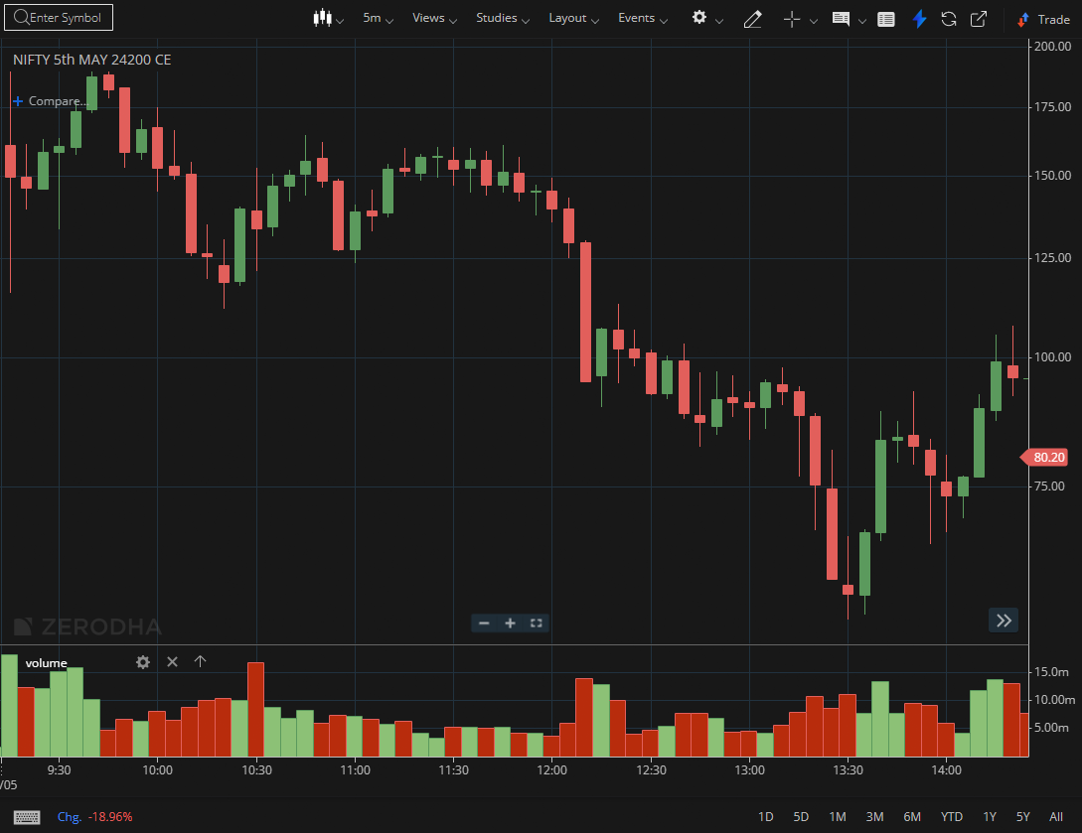
NIFTY MAY 24200 CE

1.A shallow retracement after a strong rally suggests underlying strength.
2.Price holding above the midpoint of a prior range favors continuation.
3.Expanding range with upward bias reflects increasing momentum.

