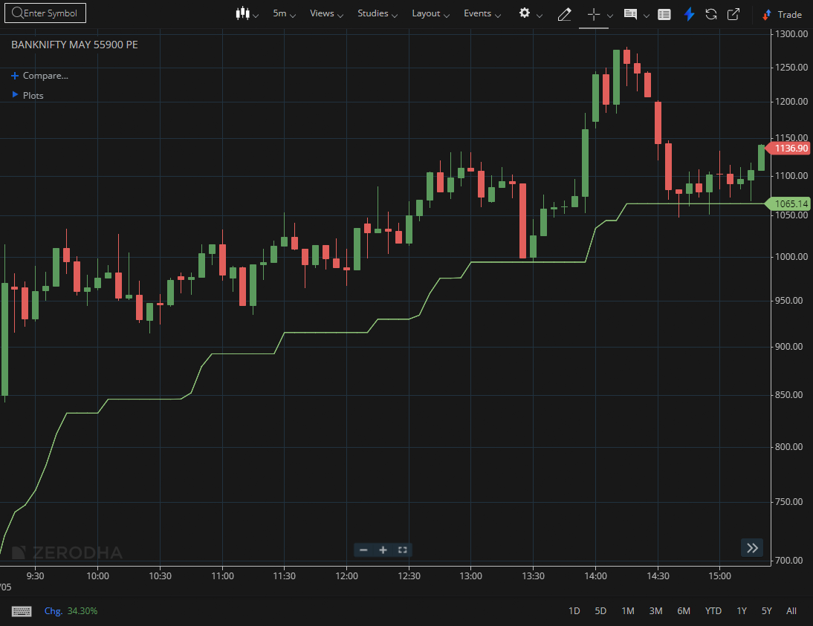
BANKNIFTY MAY 55900 PE

1.Gap-up openings with continued buying reflect positive sentiment.
2.Pullbacks toward key moving averages may offer good entry points.
3.Breaking above a previous lower high confirms a shift in market structure.

