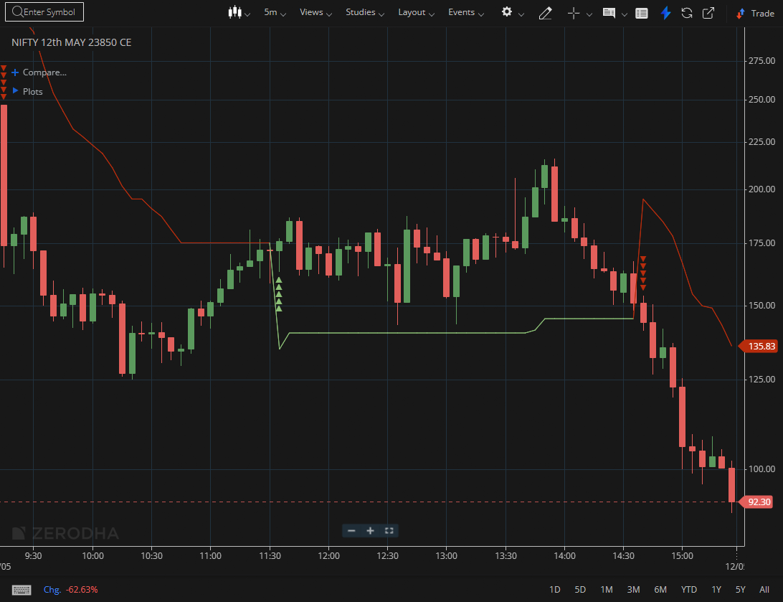
NIFTY MAY 23850 CE

1.Higher volume during breakouts often indicates participation from larger players.
2.Holding above key moving averages further strengthens the trend’s credibility.
3.Tight price movement can suggest accumulation before a potential expansion.

