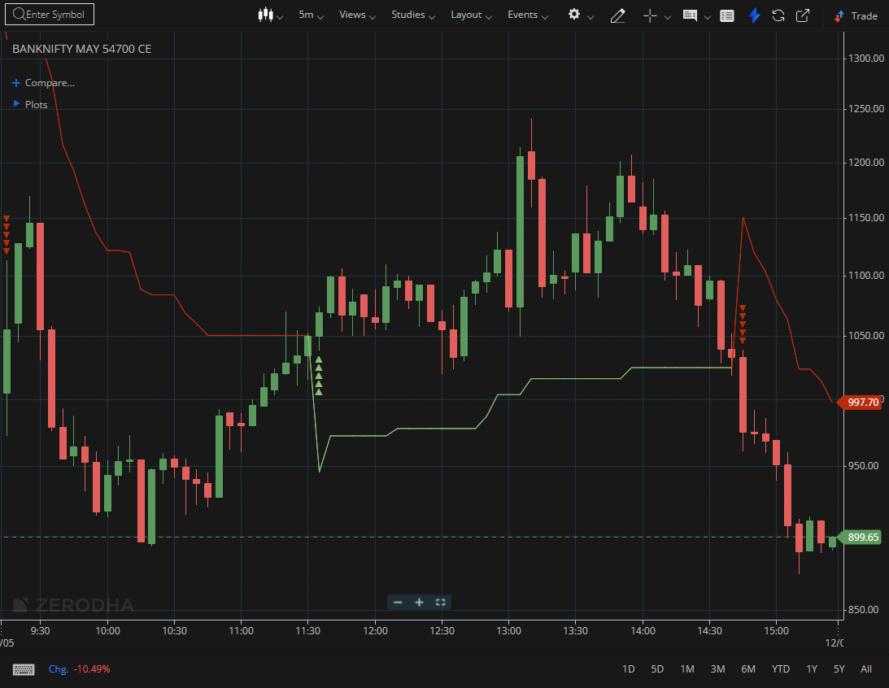
BANKNIFTY MAY 54700 CE

1.Breaking out of a long consolidation phase, especially with rising volume, highlights underlying strength.
2.Respecting an upward-sloping trendline reflects consistent buying interest.
3.A clean retest of a breakout level confirms that former resistance has turned into support.

