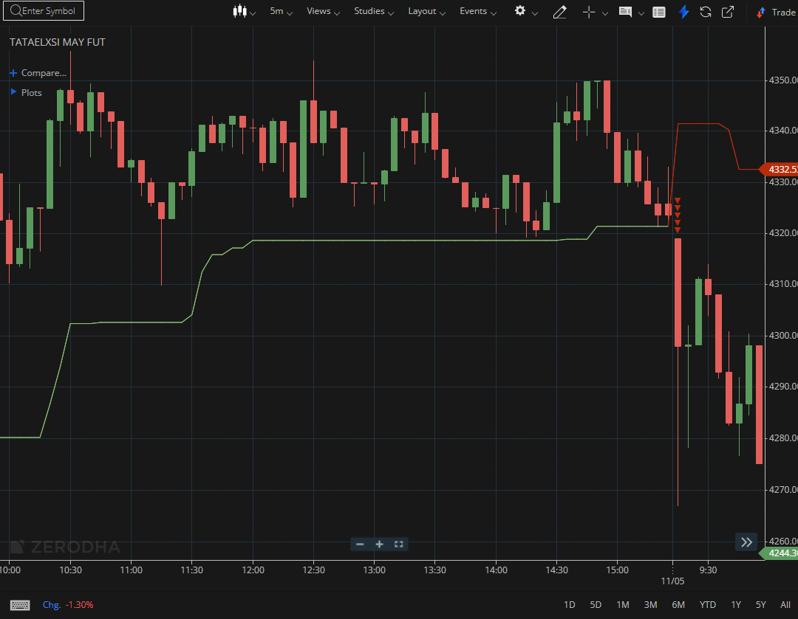
TATAELXSI MAY FUT (BTST)

1.A bullish flag pattern typically signals continuation of the ongoing trend.
2.Trading above VWAP shows buyers are in control during the session.
3.Long upper wicks near resistance hint at rejection and selling pressure.

