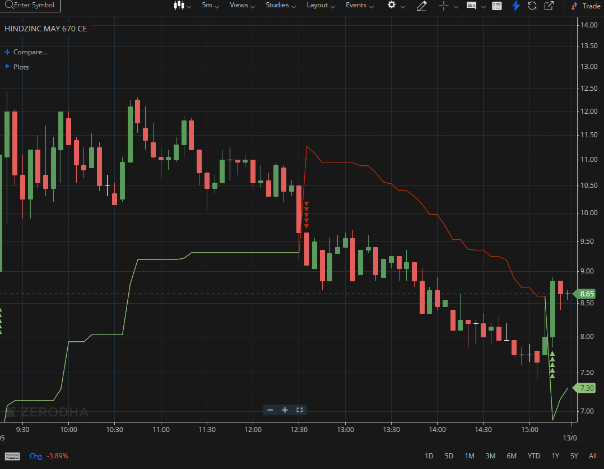
HINDZINC MAY 670 CE

1.Consolidation beneath resistance often sets the stage for a breakout attempt.
2.Holding above the opening range high suggests intraday strength.
3.Absorbing selling pressure near resistance indicates hidden buying strength.

