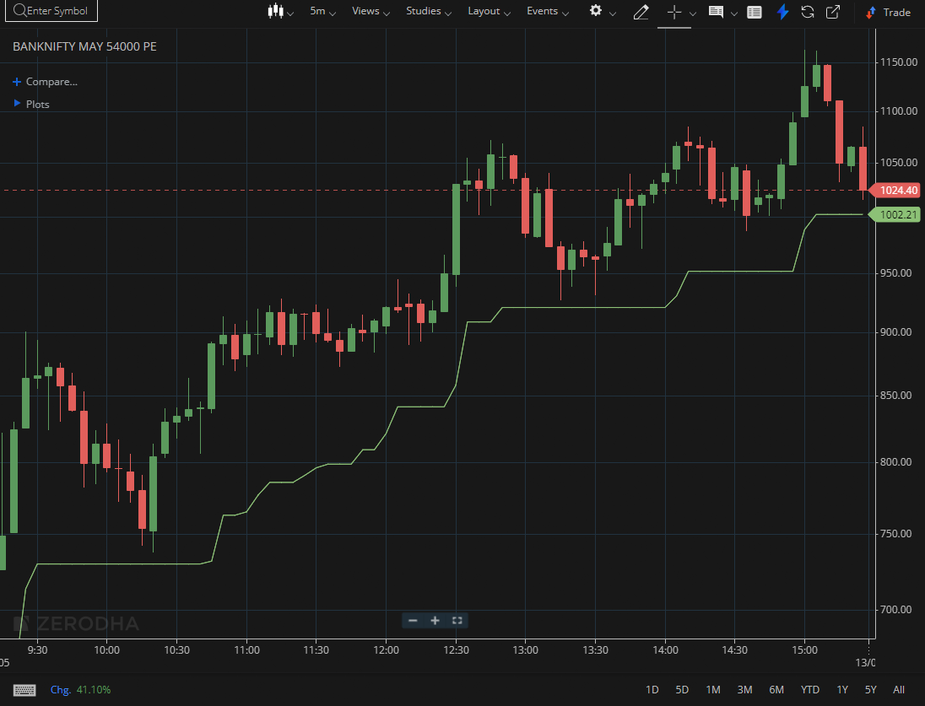
BANKNIFTY MAY 54000 PE

1.A failed breakdown followed by a reversal may signal smart money accumulation.
2.Strong closes near session highs show persistent buying demand.
3.Maintaining levels above a demand zone reinforces a bullish outlook.

