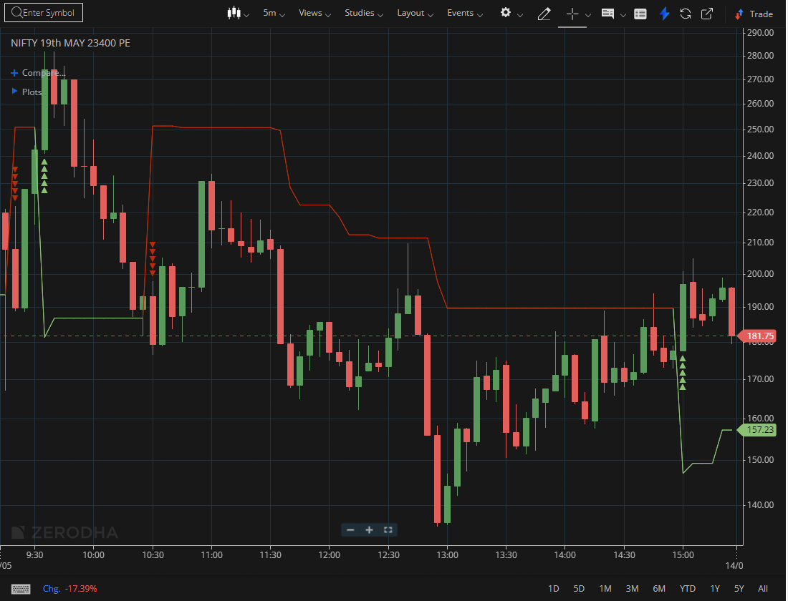

NIFTY MAY 23400 PE

1.Respecting a rising trendline indicates sustained buying support at higher levels.
2.A successful retest of the breakout zone validates the resistance-to-support flip.
3.Rising volume during a breakout signals strong market participation and conviction.

