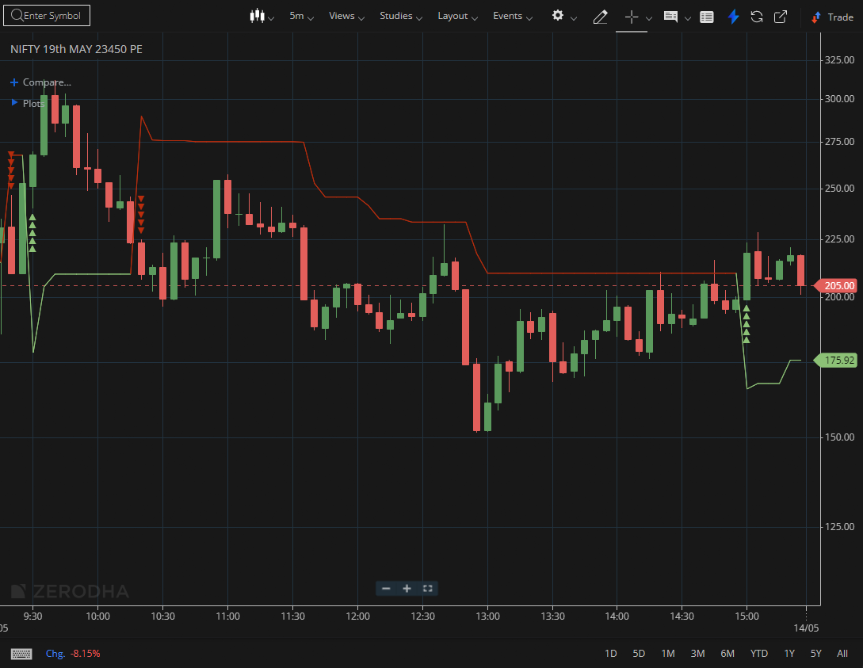

NIFTY MAY 23450 PE

1.Holding above the prior swing high suggests buyers are still firmly in control.
2.A consistent pattern of higher highs and higher lows confirms a strong uptrend structure.
3.A breakout from prolonged consolidation, backed by increasing volume, reflects strong underlying momentum.

