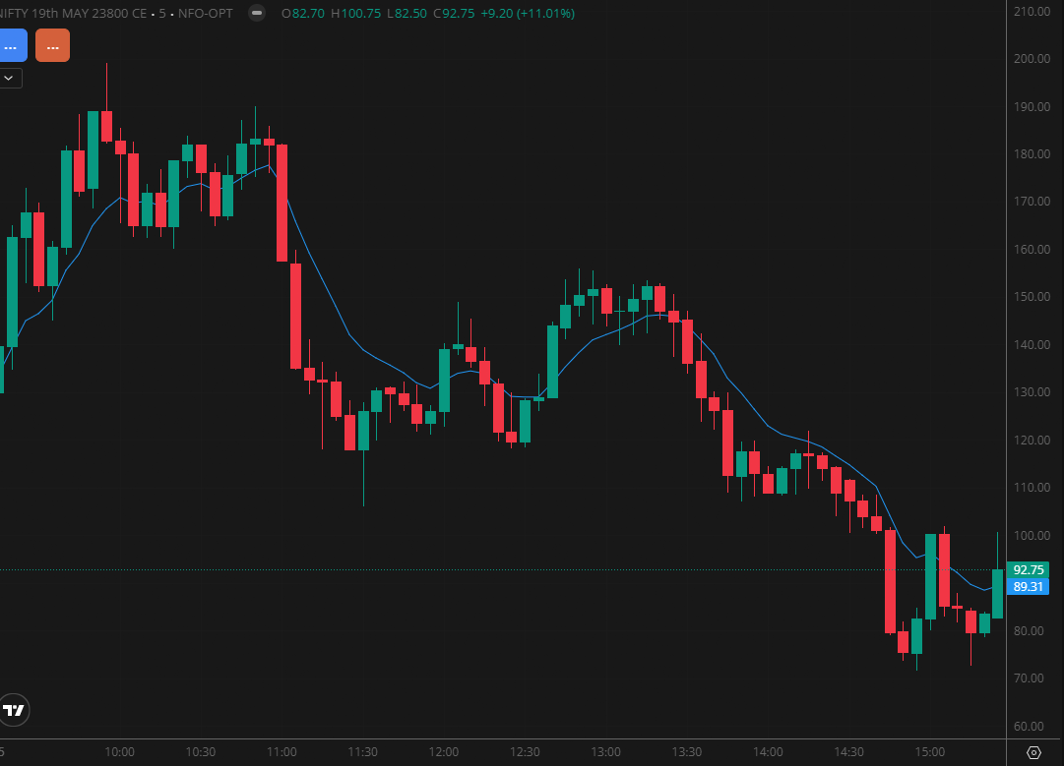
NIFTY MAY 23800 CE

1.Sustaining above major moving averages reinforces the strength of the prevailing trend.
2.Tight consolidation often points to accumulation before a potential directional expansion.
3.A bullish flag formation usually indicates continuation of the existing upward move.

