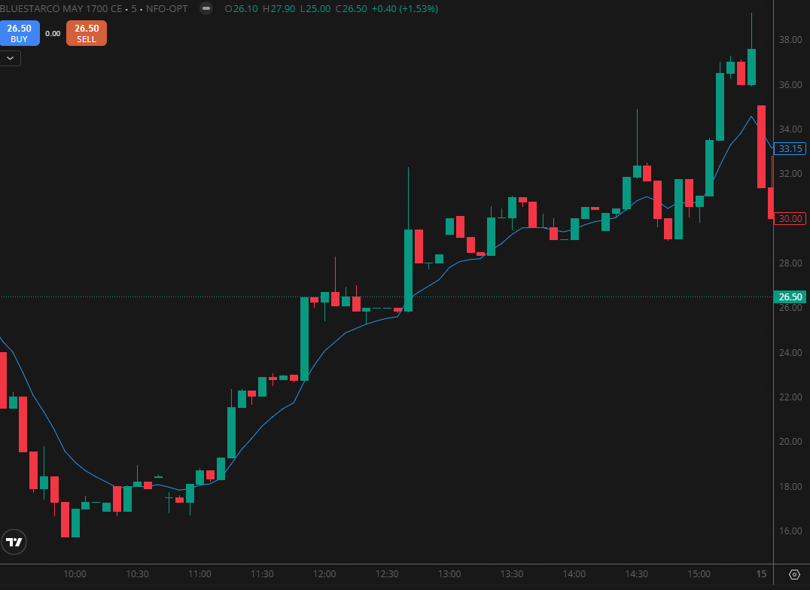
BLUESTARCO MAY 1700 CE

1.Trading above VWAP reflects intraday buyer dominance and positive sentiment.
2.Long upper shadows near resistance suggest rejection and emerging selling pressure.
3.Price approaching a demand zone may trigger renewed buying activity.

