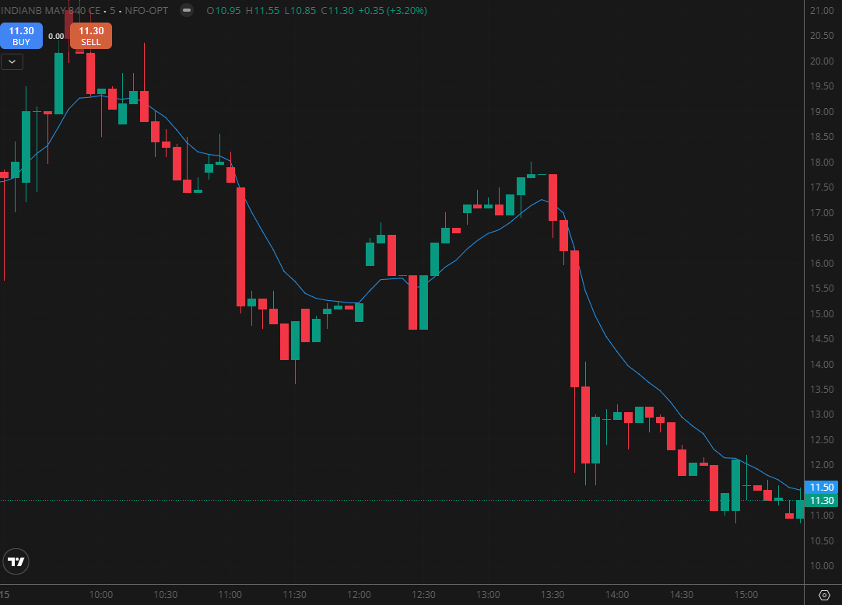

INDIANBANK 840 CE

1.A breakout above a descending trendline can indicate the early stages of a trend reversal.
2.Repeated resistance tests followed by a breakout highlight strong bullish intent.
3.Relative outperformance against the broader market demonstrates notable strength.

