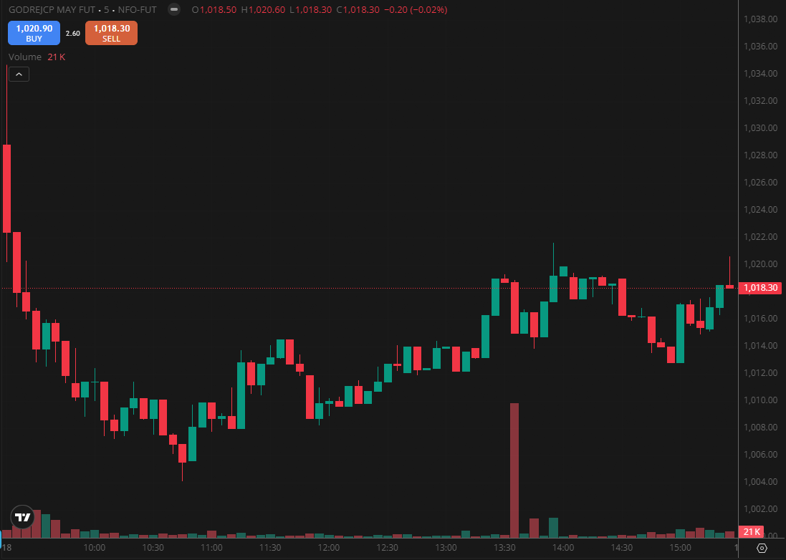
GODREJCP MAY FUT

1.A bullish flag formation usually indicates continuation of the existing upward move.
2.Trading above VWAP reflects intraday buyer dominance and positive sentiment.
3.Long upper shadows near resistance suggest rejection and emerging selling pressure.

