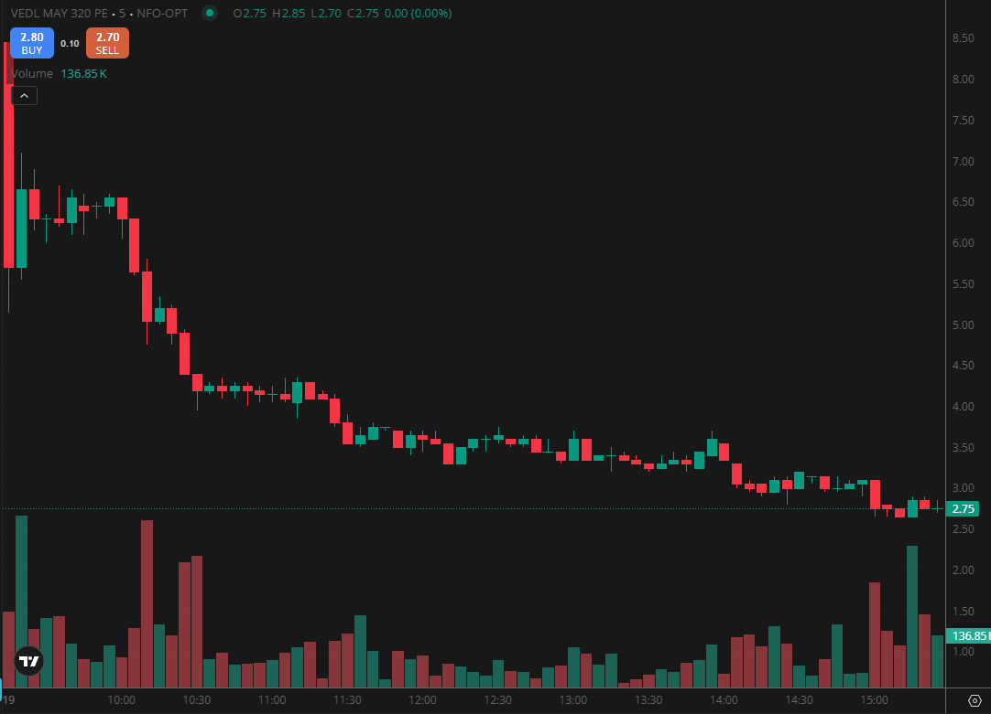
VEDL MAY 320 PE

1.A failed breakdown followed by recovery may indicate accumulation by stronger hands.
2.Strong closes near the session high reflect persistent buying interest into the close.
3.Holding firmly above a demand zone strengthens the overall bullish bias.

