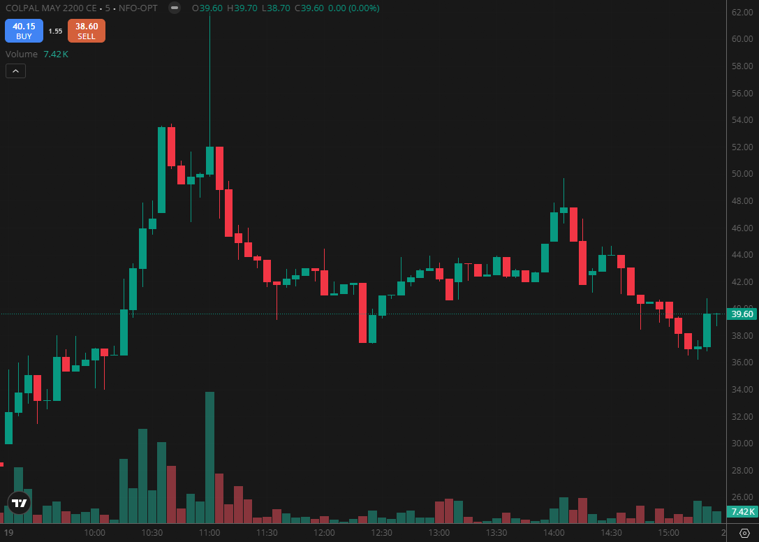
COLPAL MAY 2200 CE

1.Consolidation below resistance often builds momentum for a possible breakout move.
2.Sustaining above the opening range high reflects strong intraday momentum.
3.Absorbing supply near resistance suggests hidden strength from buyers.

