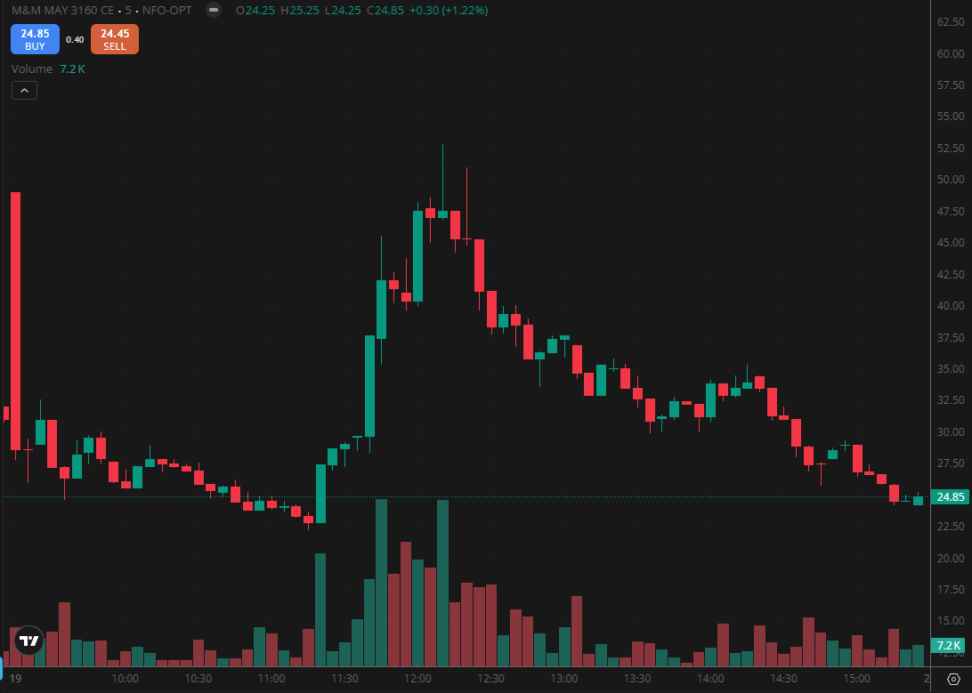
M&M MAY 3160 CE

1.Trading near all-time highs with strong momentum suggests further upside continuation.
2.Respecting Fibonacci support levels indicates active buyer defense in key zones.
3.A support breakdown accompanied by strong volume signals continued bearish pressure.

