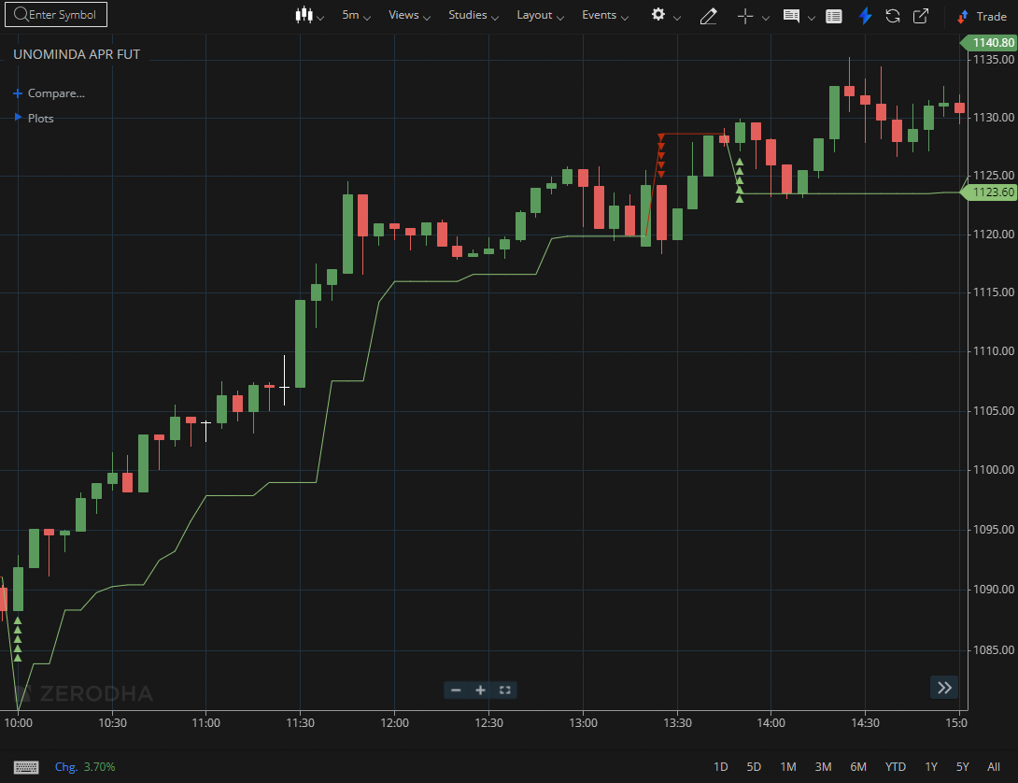
UNOMINDA APR FUT

1.Staying above important moving averages supports the strength of the trend.
2.Compressed price movement can suggest accumulation ahead of a potential expansion.
3.A bullish flag formation indicates continuation of the existing trend.

