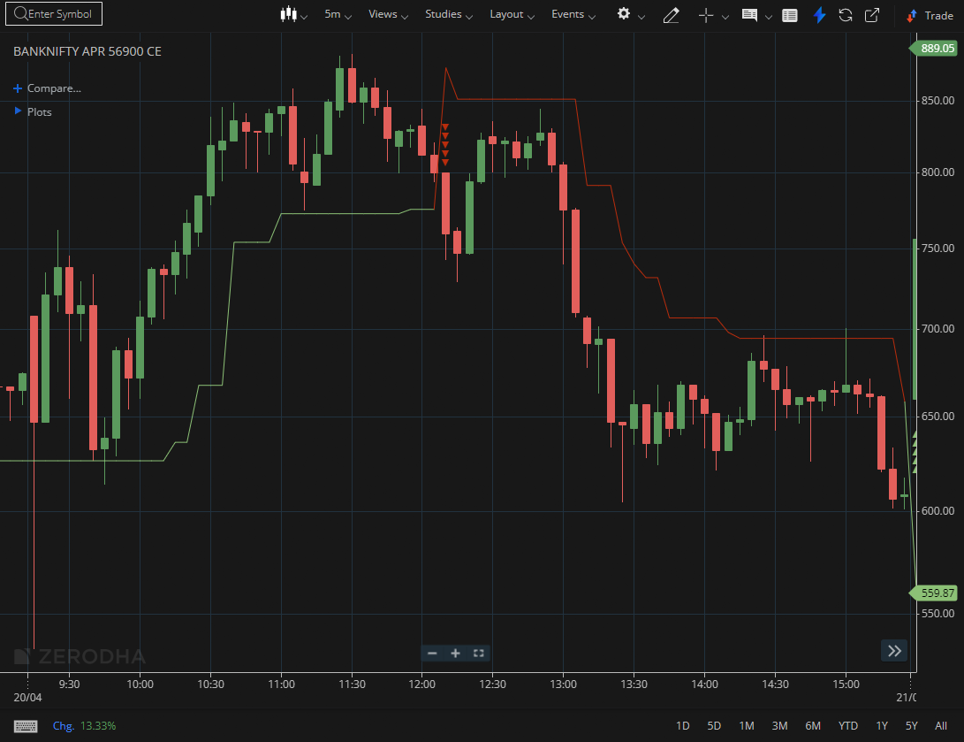
BANKNIFTY APR 56900 CE

1.Trading above VWAP shows buyers are in control during the session.
2.Long upper wicks near resistance suggest rejection and selling pressure.
3.Approaching a demand zone may attract renewed buying interest.

