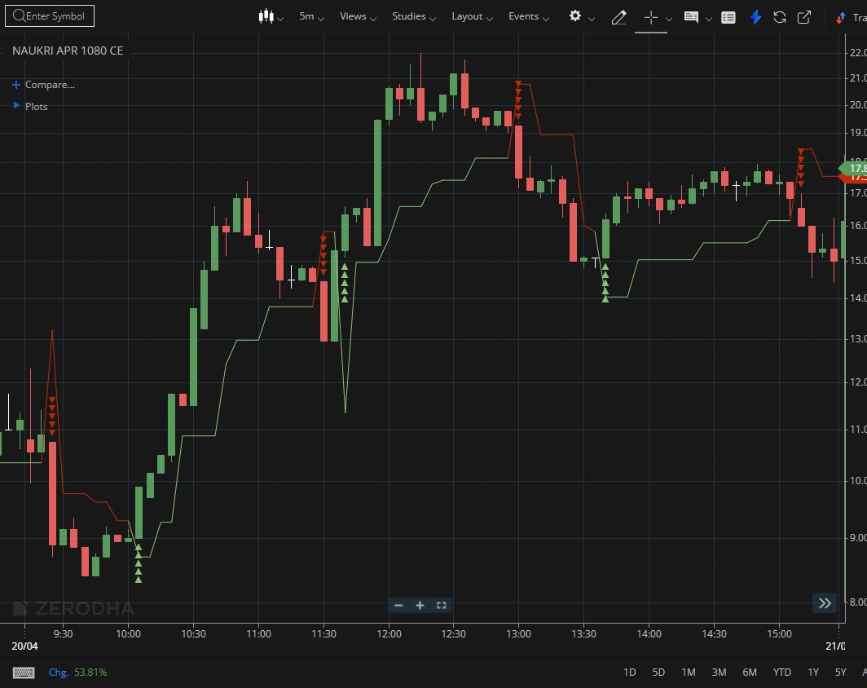
NAUKRI APR 1080 CE

1.Maintaining levels above the prior swing high signals continued bullish strength.
2.A steady formation of higher highs and higher lows reflects a clearly defined uptrend.
3.A breakout from an extended consolidation phase, especially with increasing volume, highlights underlying strength.

