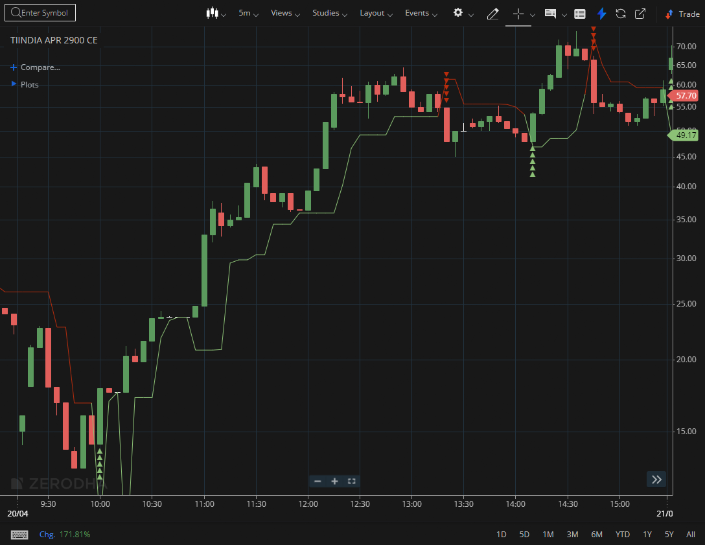
TIINDIA APR 2900 CE

1.Adhering to a rising trendline indicates consistent buying interest.
2.A successful retest of a breakout level confirms the transition from resistance into support.
3.Higher volume during breakouts points to strong participation, often from larger players.

