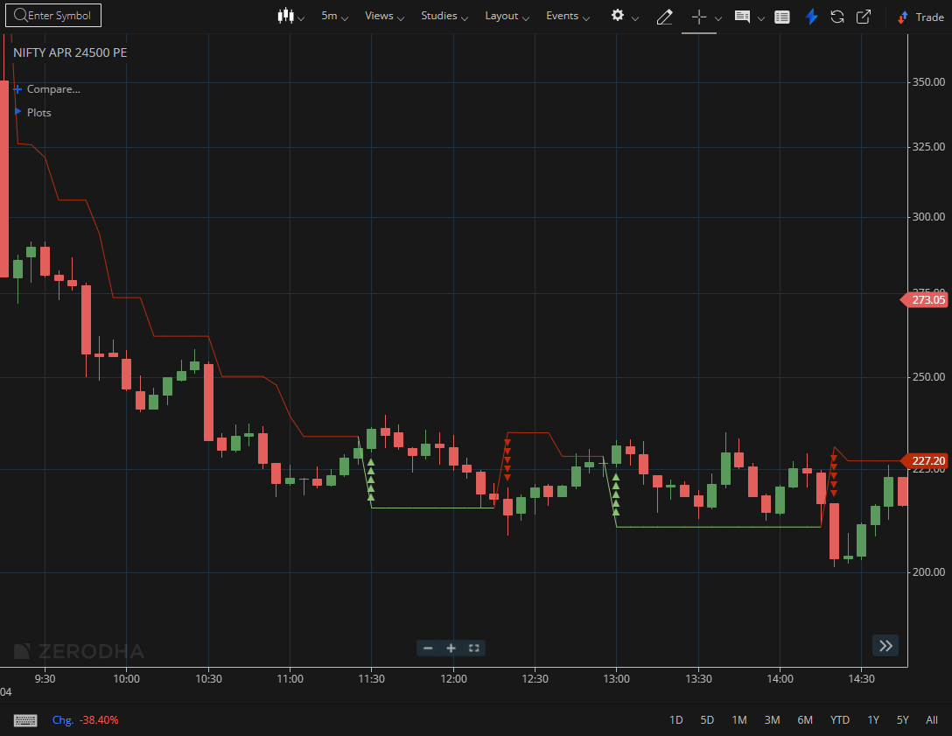
NIFTY APR 24500 PE

1.A failed breakdown followed by a reversal may suggest accumulation by informed participants.
2.Strong closes near session highs show persistent buying demand.
3.Holding above a demand zone reinforces a bullish outlook

