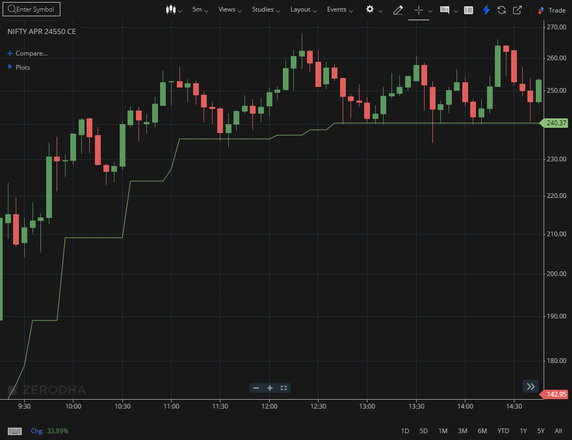
NIFTY APR 24550 CE

1.Consolidation below resistance may precede a breakout attempt.
2.Holding above the opening range high reflects intraday strength.
3.Absorbing selling pressure near resistance indicates underlying buying support.

