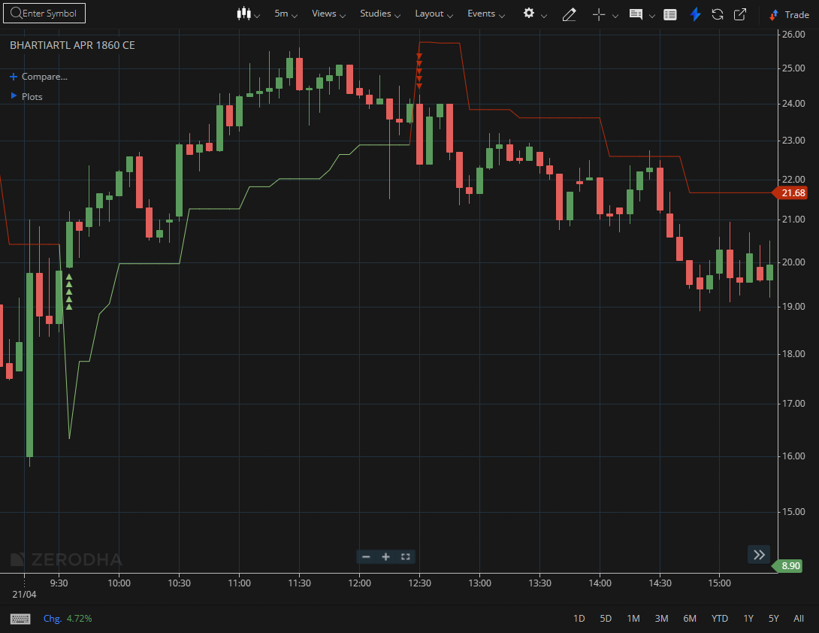

BHARTIARTL APR 1860 CE

1.Breaking above a prior lower high signals a shift in market structure.
2.Trading near all-time highs with momentum suggests further upside potential.
3.Respecting Fibonacci levels shows buyers defending critical zones.

