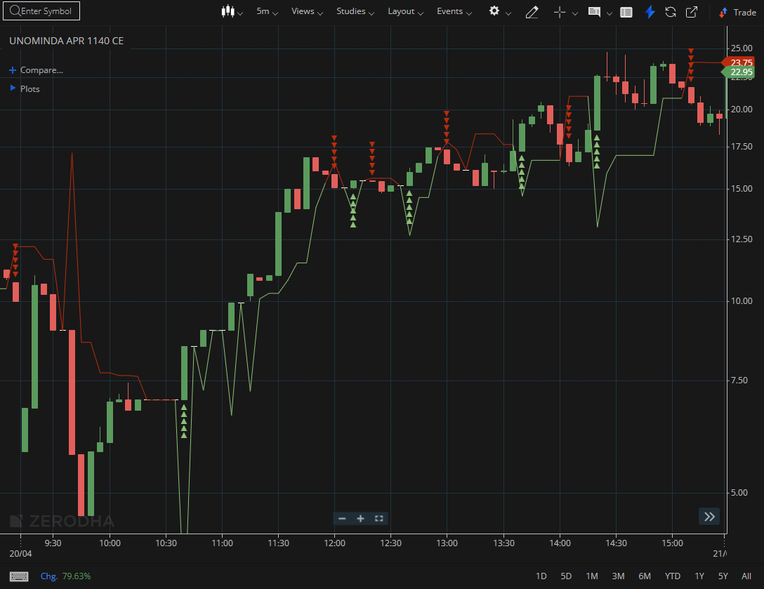
UNOMINDA APR 1140 CE

1.Frequent rebounds from support levels point toward accumulation.
2.Bullish divergence at support can signal a potential upward reversal.
3.A volatility contraction followed by expansion often leads to a strong directional move.V

