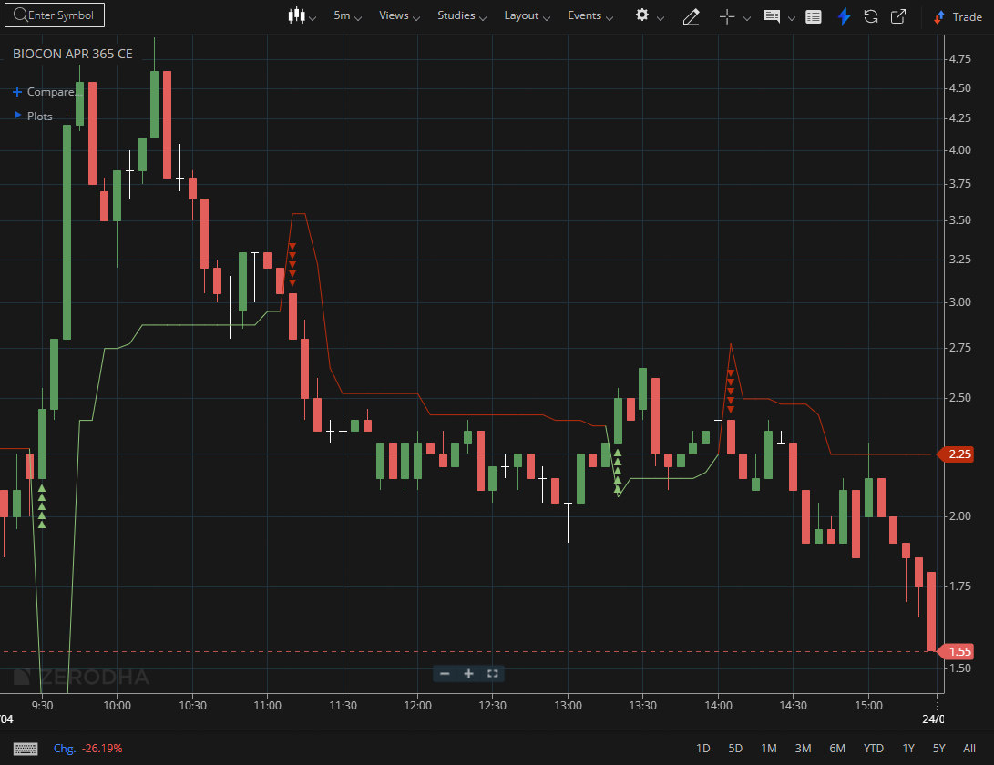
BIOCON APR 365 CE

1.A move above a downward-sloping trendline hints at a possible trend reversal.
2.Repeated rejections followed by a breakout indicate strong bullish conviction.
3.Outperforming the broader market demonstrates notable relative strength.

