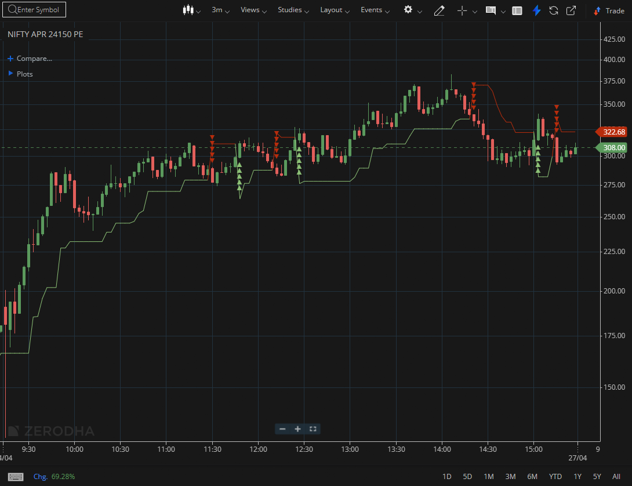
NIFTY APR 24150 PE

1.Holding above a previous swing high points to sustained bullish momentum.
2. A consistent pattern of higher highs and higher lows signals a well-established uptrend.
3.When price breaks out of a prolonged consolidation—especially on rising volume—it often reveals strong underlying demand.

