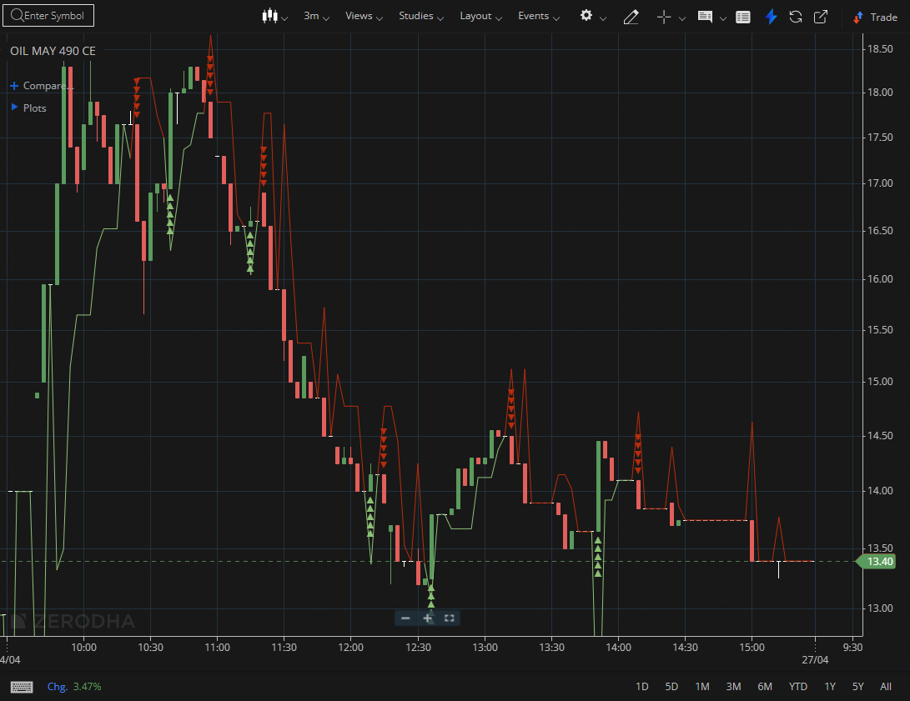
OIL MAY 490 CE

1.Rising volume during breakouts suggests strong participation, often from institutional players.
2.Staying above key moving averages reinforces the strength of the trend, and periods of tight price action can indicate accumulation before a potential expansion.
3.Bullish flag patterns typically signal continuation, and trading above VWAP shows buyers are controlling the session.

