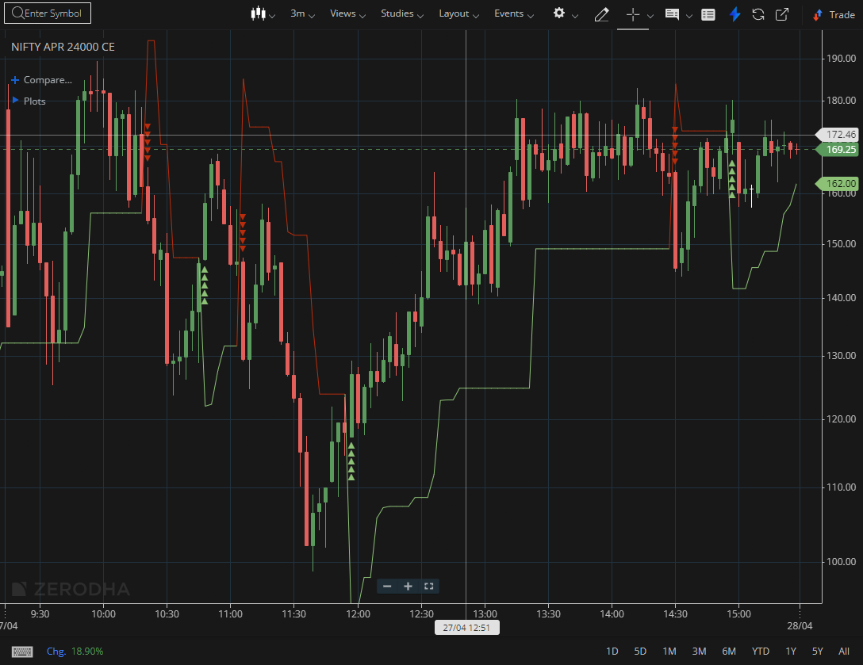
NIFTY APR 24000 CE

1.On the flip side, long upper wicks near resistance highlight rejection and selling pressure.
2.As price approaches demand zones, buying interest may return.
3. A break above a descending trendline can hint at a possible reversal, and repeated rejections followed by a breakout show strong bullish intent

