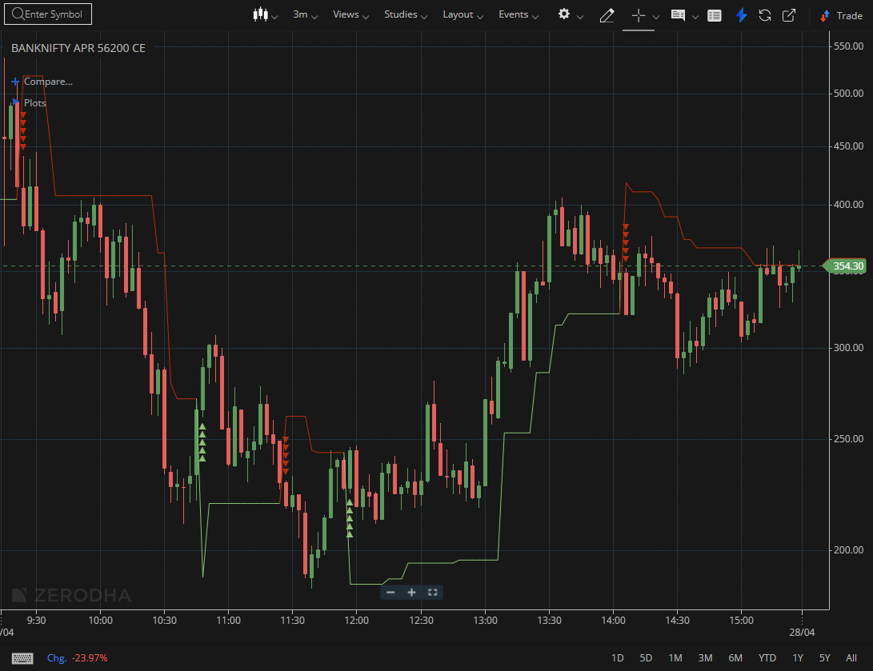
BANKNIFTY APR 56200 CE

1.Outperformance relative to the broader market indicates notable strength, while repeated bounces from support suggest accumulation.
2.Bullish divergence at support can precede an upward move, and volatility contraction followed by expansion often leads to a decisive trend.
3.Gap-up openings that hold gains reflect positive sentiment, while pullbacks toward key moving averages may offer entry opportunities.

