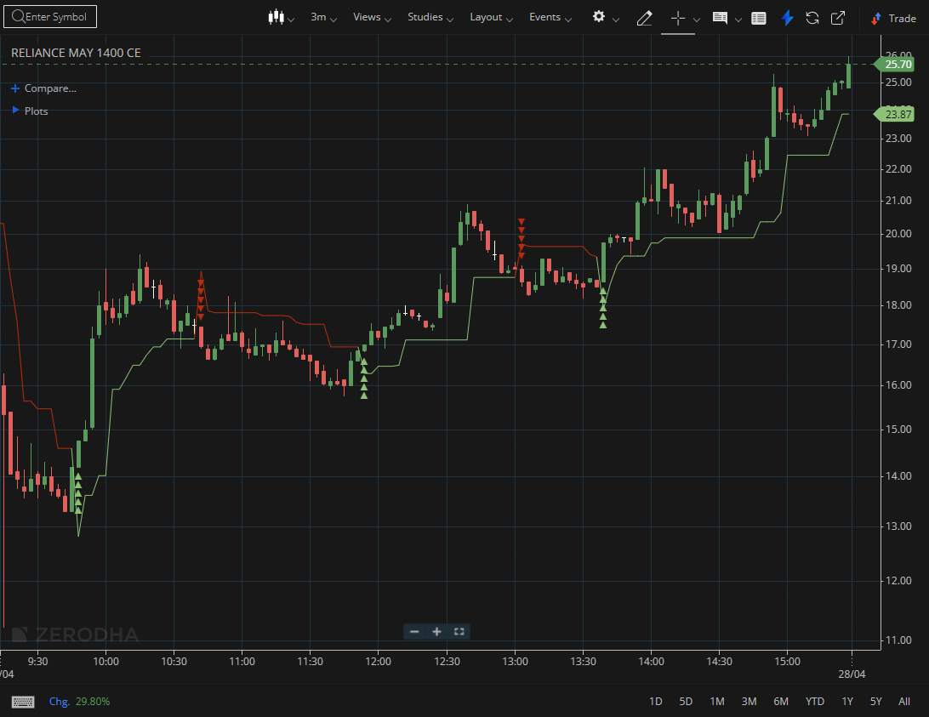

RELIANCE MAY 1400 CE

1.Maintaining support above a recent breakout level suggests buyers are still in control.
2.A sequence of tight consolidations within an uptrend often signals continuation.
3.Higher lows forming near support indicate sustained accumulation.

