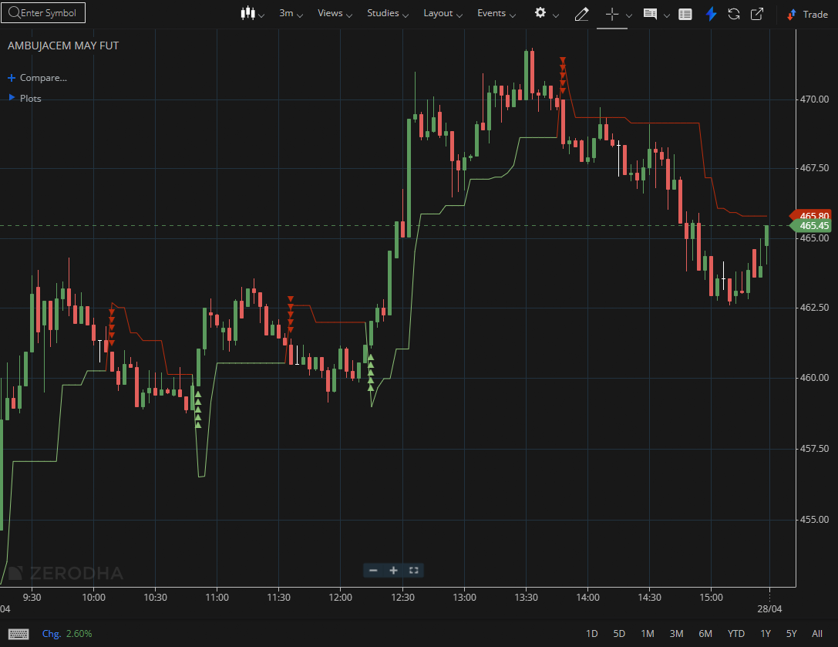
AMBUJACEM MAY FUT

1.Respecting Fibonacci levels shows buyers defending important zones.
2.In contrast, a breakdown below support on increasing volume confirms bearish continuation.
3.Consolidation below resistance can set up a breakout attempt, and holding above the opening range high signals intraday strength.

