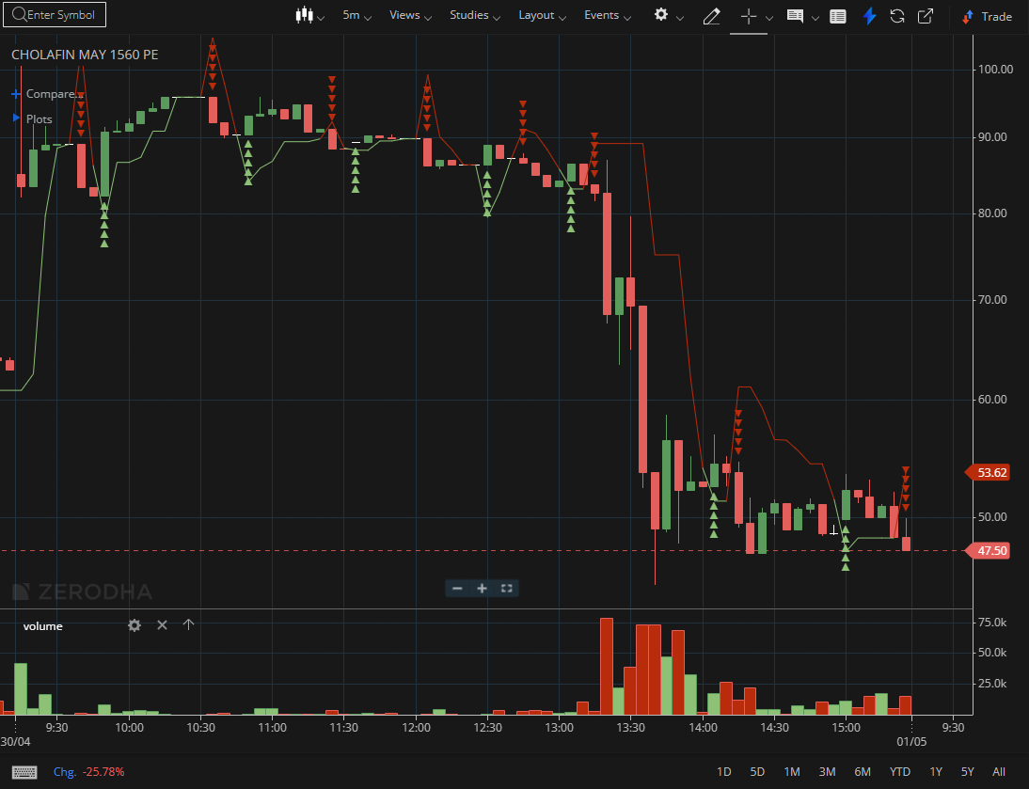

CHOLAFIN MAY 1560 PE

1.An increase in open interest alongside rising price can validate trend continuation.
2.Bullish continuation gaps often lead to further upside when supported by volume.
3.Consolidation near highs indicates strength rather than exhaustion.

