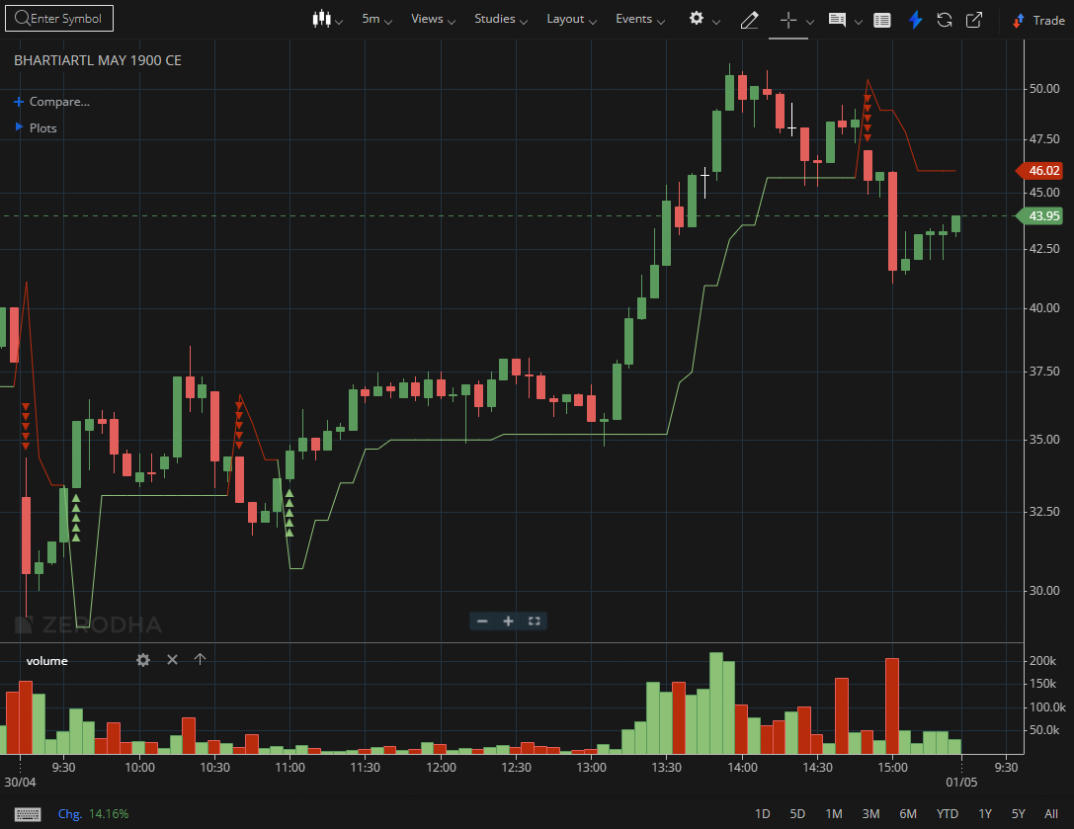
BHARTIARTL MAY 1900 CE

1.Steady upward drift with low volatility can precede a breakout expansion.
2.Repeated defense of a support zone highlights buyer commitment.
3.A breakout retest that forms a higher low adds confirmation to the trend.

