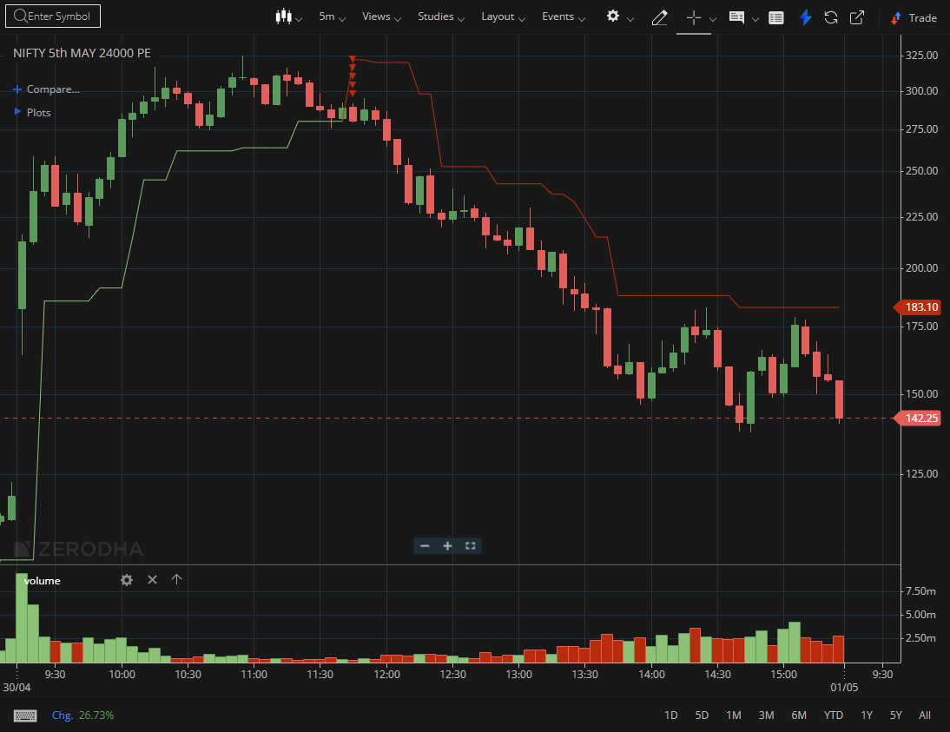

NIFTY MAY 24000 PE

1.Price holding above the midpoint of a prior range favors continuation.
2.Expanding range with upward bias reflects increasing momentum.
3.Support flips from previous resistance confirm structural strength.

